



REPUBLIC OF UGANDA

Ministry of Gender Labour & Social Development

**SYSTEM USER MANUAL**

FOR THE UPGRADRE OF THE GBV/VAC HELPLINE SYSTEM

Submitted By

October 2021

Table of Contents

Table of Figures iii

1 Introduction 1

1.1 System components 1

1.2 Requirements for using the system: 1

2 Installations 1

2.1 Browser installation 1

3 The Helpline System 2

3.1 Accessing the system 2

3.1.1 Helpline System Login 2

3.2 Call & Queue Management 2

3.2.1 Queue Status 2

3.2.2 User Profile 3

3.2.3 Integrated Softphone 4

3.2.4 Receiving A call 4

4 Case Capture 5

4.1 Reporter Details 5

4.2 Case type action 6

4.2.1 Case Follow Up 6

4.2.2 Information Inquiry. 7

4.2.3 Counselling 7

4.2.4 New Case 7

4.3 Case Details 7

4.3.1 Case Fields 7

4.3.2 Reporter Details Update 7

4.3.3 Client Details 8

4.3.4 Perpetrator Details 9

4.3.5 Case View 10

4.3.6 Case Update 11

4.3.7 Case Edit 11

4.4 Disposition 12

5 Dashboards 12

5.1 User Dashboards 12

5.2 Wall Dashboard 1

6 Calls 1

7 Quality Assessment 2

8 Contact list 4

9 Other Sources 6

9.1 Emails 6

9.2 SMS 6

9.3 Creating a case 6

10 Reports 6

10.1 Call reports 6

10.1.1 Call List 6

10.1.2 Call Pivot Report 6

10.2 Case reports 7

10.2.1 Case List 7

10.2.2 Case Report Pivot 8

11 System Notifications & Other Sources 9

12 Web Page 10

13 Mobile Application 11

14 System Settings 11

14.1 Users 12

14.2 Campaigns 13

14.3 IVR Prompts 14

14.4 Categories 15

15 Conclusion 16

16 User Manual Sign-Off 1

# Table of Figures

Figure 1:Chrome browser downloading 1

Figure 2: Installation Complete 1

Figure 3: Login Page 2

Figure 4:SIP Queue Status 3

Figure 5: SIP Phone & Making a call 3

Figure 6:Selected Reporter Details 4

Figure 7:Reporter Form 5

Figure 8: Case Type Action 5

Figure 9: Follow Up Case list 5

Figure 10: Case Details 6

Figure 11: Reporter Details Update 7

Figure 12: Client Details 8

Figure 13: Added clients listing 8

Figure 14: Perpetrator Details 9

Figure 15: Case action and status 10

Figure 16: Case Update View 10

Figure 17: Form Disposition 11

Figure 18: Call Disposition Reasons 11

Figure 19: Case Report Filters 12

Figure 20: Generic Dashboard 13

Figure 21: Incoming Call 13

Figure 22: Incoming Call Options 13

Figure 23: Hang-up Reasons 14

Figure 24:Contact List 15

Figure 25:Individual Contact View 15

Figure 26: Individual Contact Edit 16

Figure 27: Report Options 17

Figure 28: Case Report Listing 18

Figure 29: Case Report List Filters 18

Figure 30: X-Axis Case Report Filters 19

Figure 31: Case Pivot Report 19

# Introduction

This solution is an upgrade of the helpline call and case management system currently handling VAC cases to incorporate GBV cases and case management. This is a documentation of the different components to guide the users in the daily operations and configurations on the different modules.

## System components

The solution is made up of a number of modules including call management, case management, quality assessment and additional media channels such as email, SMS & social media.

## Requirements for using the system:

* A computer
* Good internet connectivity (Optional for core items)
* A browser

# Installations

## Browser installation

A user is at liberty to use any browser they are comfortable with. Chrome browser is highly recommended for the system. To install the Chrome browser;

1. Go to https://www.google.com/chrome.
2. Click Download Chrome.
3. Check the box that asks if you want to make Chrome the default browser.
4. Click Accept and Install.
5. Go to the folder of downloads and locate the setup download by searching ChromeSetup.exe
6. Click on the setup. A dialog box will appear on the screen asking if you want to allow the program to make changes to the computer. Click yes to agree to the installation.
7. Chrome browser will start downloading and installing.

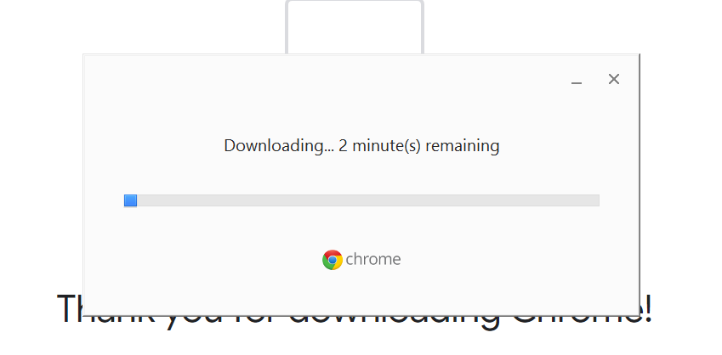

Figure :Chrome browser downloading

1. Once the installation is done, you will be prompted to close the process and the browser will be launched.

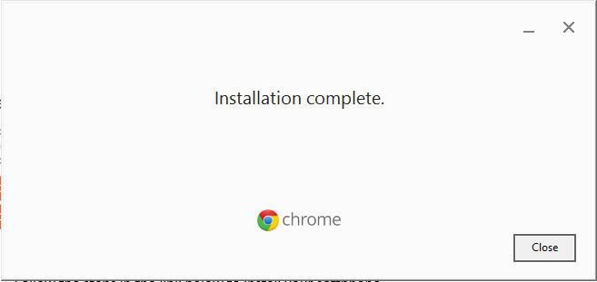

Figure : Installation Complete

# The Helpline System

## Accessing the system

The system shall be accessible to users upon installation via a dedicated IP address for users within the helpline centre and via a public link for remote users. The IP and link shall be accessible on any modern browser. The links are as follows:

Local IP: 172.16.3.2

Public Link: sauti.mglsd.go.ug

### Helpline System Login

A login page will appear as shown in Figure 9 once one accesses the links provided. The user is required to type in the username and password provided by the administrator and click the sign-in button to access the helpline account using.

* Username e.g test
* Password e.g P@ssw0rd

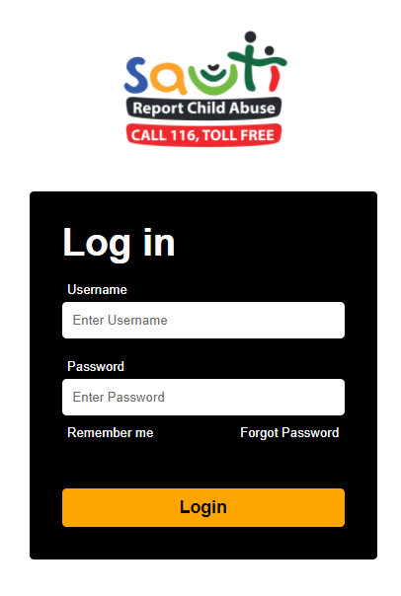

Figure : Login Page

## Call & Queue Management

### Queue Status

Users with call option are able to manage their time and availability for calls easily using status options provided which include: Available, Coffee Break & Lunch Break.

The queue status dropdown shows the current users extension number assigned during user creation.

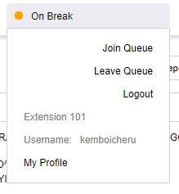

Queue Status Options

Extension Number

User Profile

Figure :SIP Queue Status

### User Profile

This displays personal details for the person currently logged in. This also provides an option for one to change their password to one of their liking.

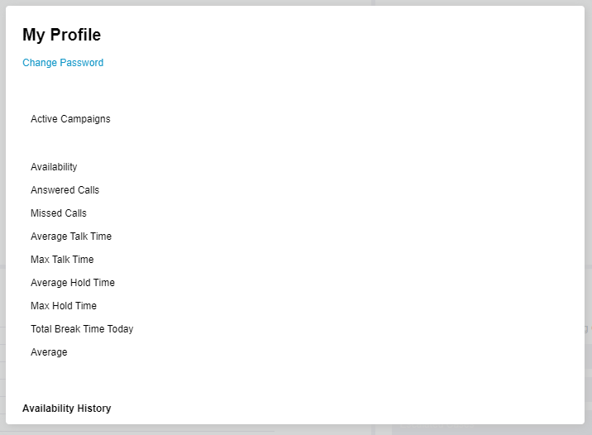

Figure : User profile view

Change Password

The change password button under the user profile gives the user the form as shown in the figure below. To change the password, one needs to have the current password and match the new password in the fields provided.

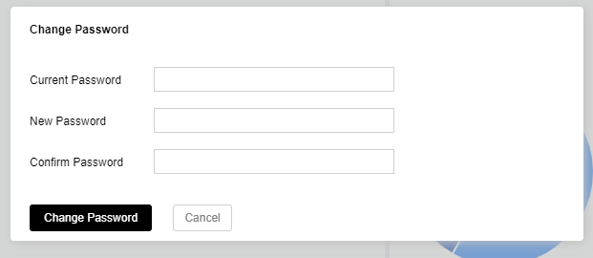

Figure : Change password form

### Integrated Softphone

Softphone for receiving and/or dialling out is integrated within the CRM. On dialling a number, it looks like in the diagram below:

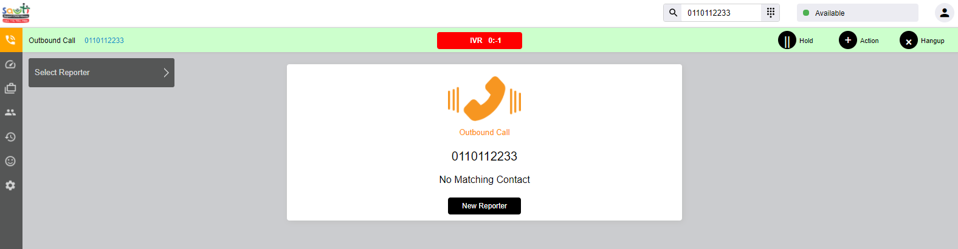

Dialed Number

Phone On-Call Actions

Figure : SIP Phone & Making a call

### Receiving A call

When a call comes in from an outside line, the sip phone rings and upon receiving, a case form pops for case creation further explained in Case Capture Section.

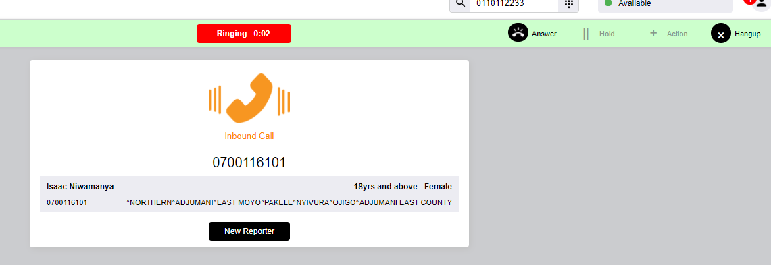

When the reporter exists and is selected, the reporter details form is pre-populated and the user can proceed to the next section, otherwise the user can click on the “New Reporter” button to created new details.

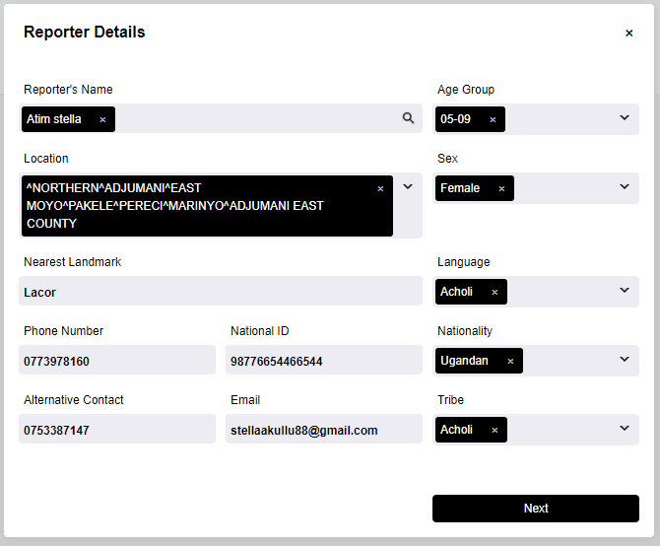

Figure :Selected Reporter Details

# Case Capture

There is a universal case capture form taking into consideration the different case sources which include but not limited to call, walkin, SMS, email, SafePal, etc.

The case form fields are grouped into reporter details, client details, case details, perpetrator details and case status details. The case capture process is as described in the steps below.

## Reporter Details

For a call cases, the system searches automatically if the caller number has any existing call details which shall be populated under reporter details. If there is no history, then user creates a new reporter.

For a walkin case, a system user can search the system contacts with the reporter name.

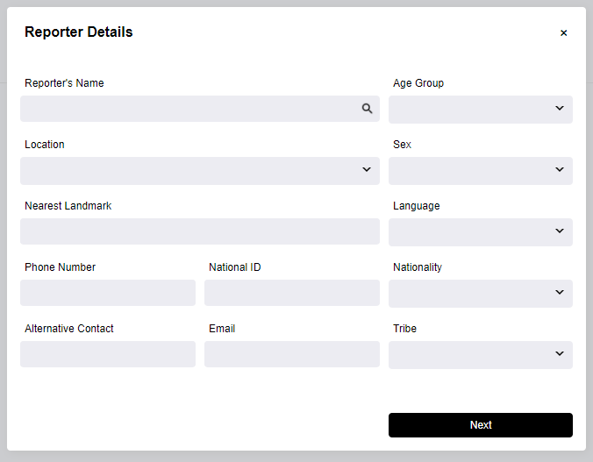

Figure :Reporter Form

## Case type action

The caller does not necessarily call to report a case, so the system has an option for other call classification which are necessary for data capture which include: Service, Follow Up, Information Inquiry and New Case report as shown in the figure below. This has four sections: filling of case details, update of reporter details, creating perpetrators and creating clients.

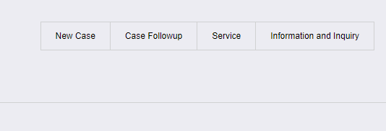

Figure : Case Type Action

### Case Follow Up

This is for reporters who are following up on the status or giving an update of previously created cases. This presents a list of cases under the reporter’s phone number and a form to search for other cases. The cases shall be listed and the selected case is opened for further update as described in the Case Update Section.

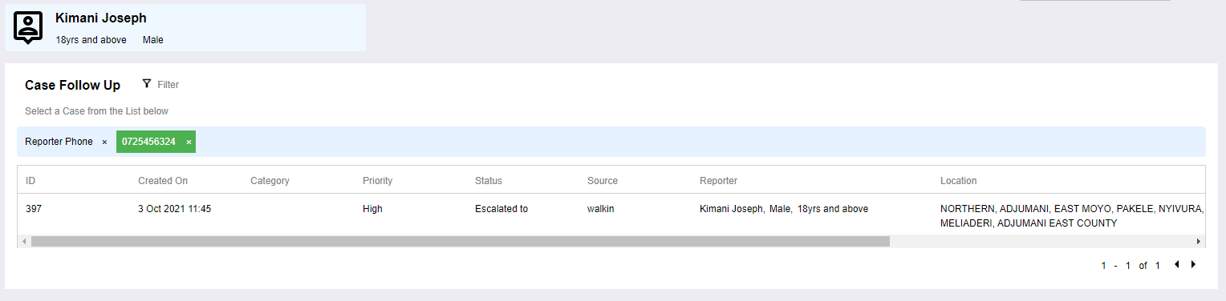

Figure : Follow Up Case list

### Information Inquiry.

This leads to an FAQ and information page and/or form. The content of FAQs shall be always updated by system administrators and during the call when the information Inquiry is selected and the question asked does not exist.

SCREENSHOT

### Counselling

This refers to counselling service offered to callers who do not necessarily have an abuse case to be recorded. When this option is selected, a form with counselling category field, narrative, service offered and service comments by agent is opened for the agent to fill.

SCREENSHOT

### New Case

This takes us to the case form described in Case Form Section of this documentation where the user creates a case as described under Case Fields section.

## Case Details

These are the fields relating to the specific case as explained by the reporter to the system user.

### Case Fields

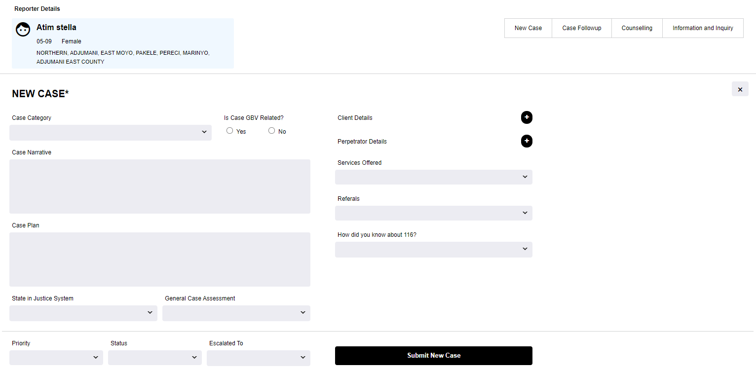

Figure : Case Details

The new case report section has additional items captured which include: Client details, perpetrator details, case status and an option to update reporter details.

### Reporter Details Update

Reporter details are being edited since they have already been created.

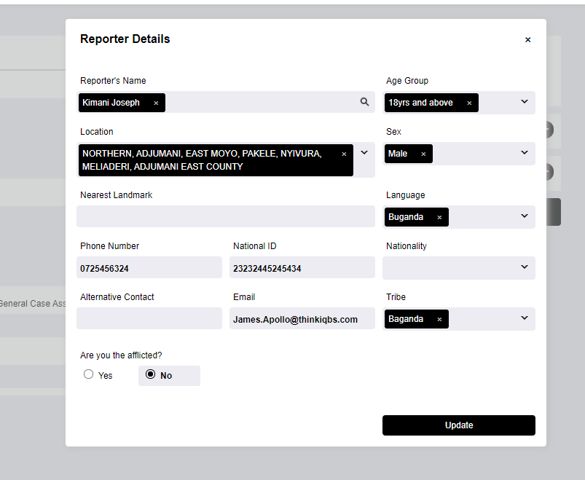

Figure : Reporter Details Update

### Client Details

Client details are captured in the form presented when once clicks the plus sign next to “Client Details” label. More than one clients can be added and they shall be listed as below:

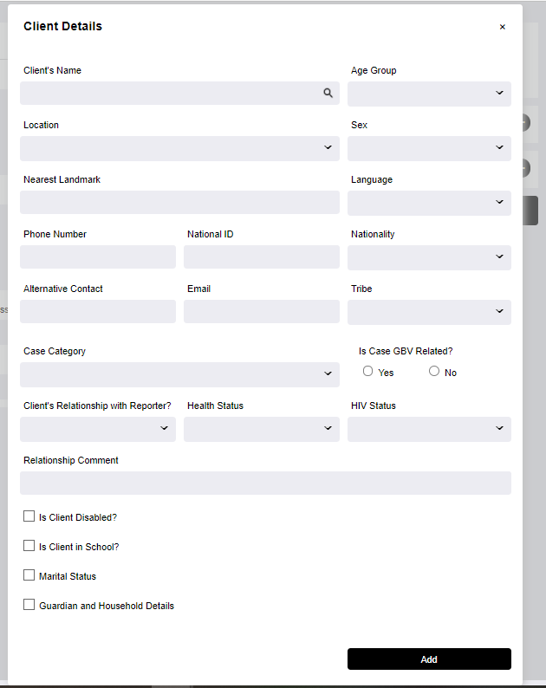

Figure : Client Details

One can add more than one clients and perpetrators but clicking the  sign next to the respective label. The added clients and/or perpetrators shall be listed for update as show in the diagram below:

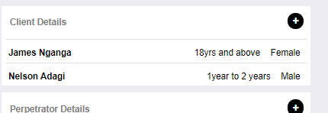

Figure : Added clients listing

### Perpetrator Details

Perpetrators can be added at this point and a case can have more than one perpetrators, each one will be added and listed in the perpetrators section.

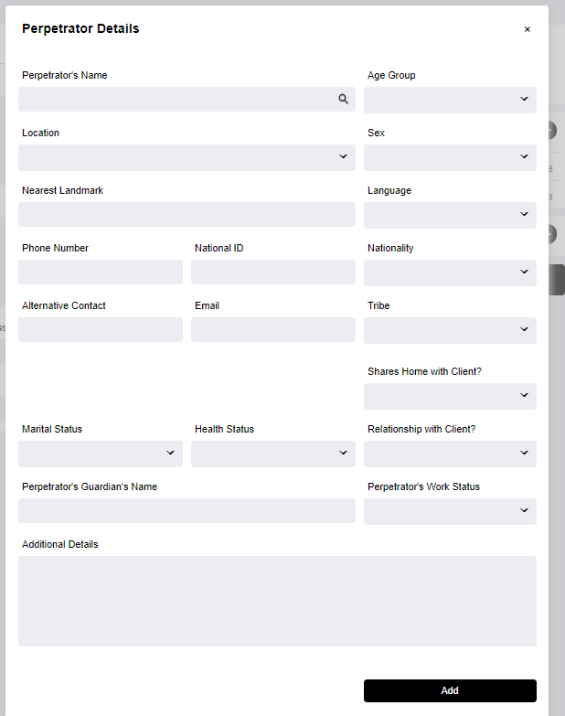

Figure : Perpetrator Details

Added perpetrators shall also have a listing as described for client in diagram on “*Added Clients Listing*”

### Case View

This provides a platform for viewing the created cases, once a case has been submitted, a user will be redirected to the case view. From the case view page, one has an option to edit the case, print or export to PDF.

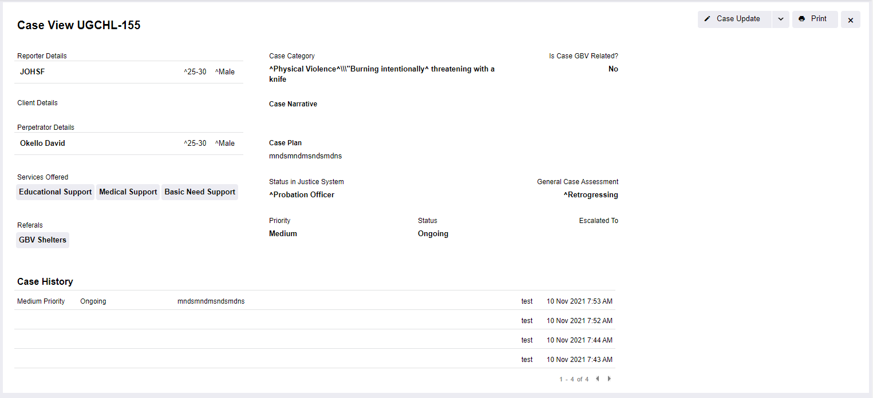

Figure : Case View

### Case Update

When an old case is selected for update, the case details are presented in an editable form with the fields being prefilled. The case related information such as reporter, client and perpetrator details are as in the case capture form. The case update option does not allow for a change on the case narrative.

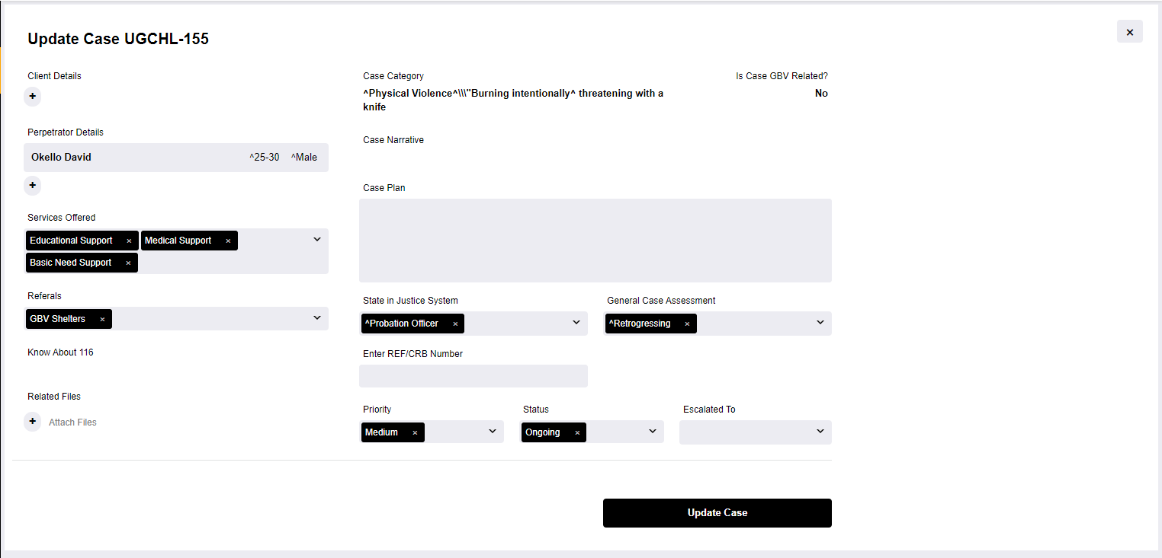

Figure :Case Update View

### Case Edit

Case edit allows for the editing of the case narrative by either a supervisor, a case manager and/or the person who created the case. Counsellors and Caseworkers who did not create a case can only do a case update. The case edit button is available as a dropdown on the case update button.

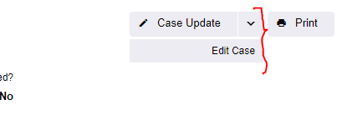

Figure : Case Edit

## Disposition

The agent might need to dispose of the call due to some reasons. This will be catered for under the disposition segment. The disposition options shall be configured by the administrator.



Figure : Form Disposition

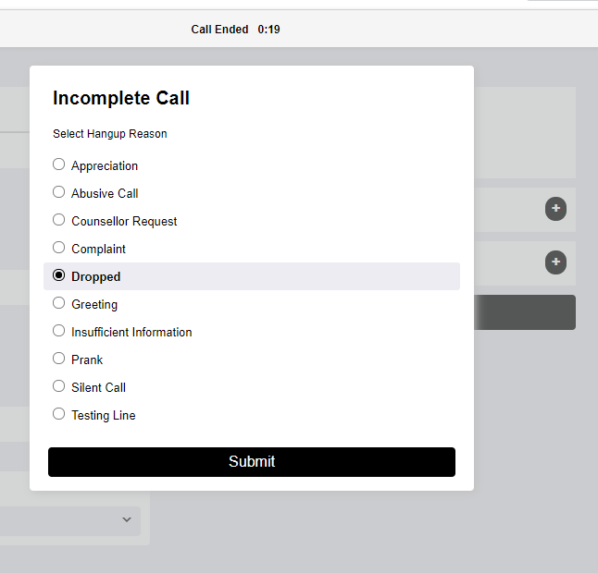

Figure : Call Disposition Reasons

Figure : Case Report Filters

# Dashboards

## User Dashboards

The user can carry out multiple roles depending on the user rights given, as seen through the elements on the dashboard in Figure below.

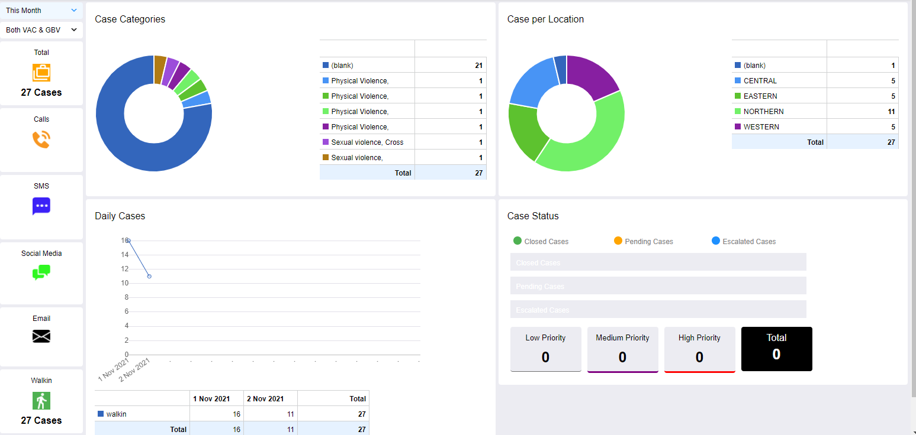

Figure : Generic Dashboard

## Wall Dashboard

This dashboard displays real-time statistics of the helpline System and is meant for centre management. This helps in the monitoring of the Helpline service delivery and daily activities.

WALL DASHBOARD

# Calls

Calls is a major source of cases to the helpline. When a call comes in, it will ring on the agents/counsellors on queue one by one. The diagram below shows an incoming call with options to receive or reject. Details related to the calling number are displayed if they already exist within the system.

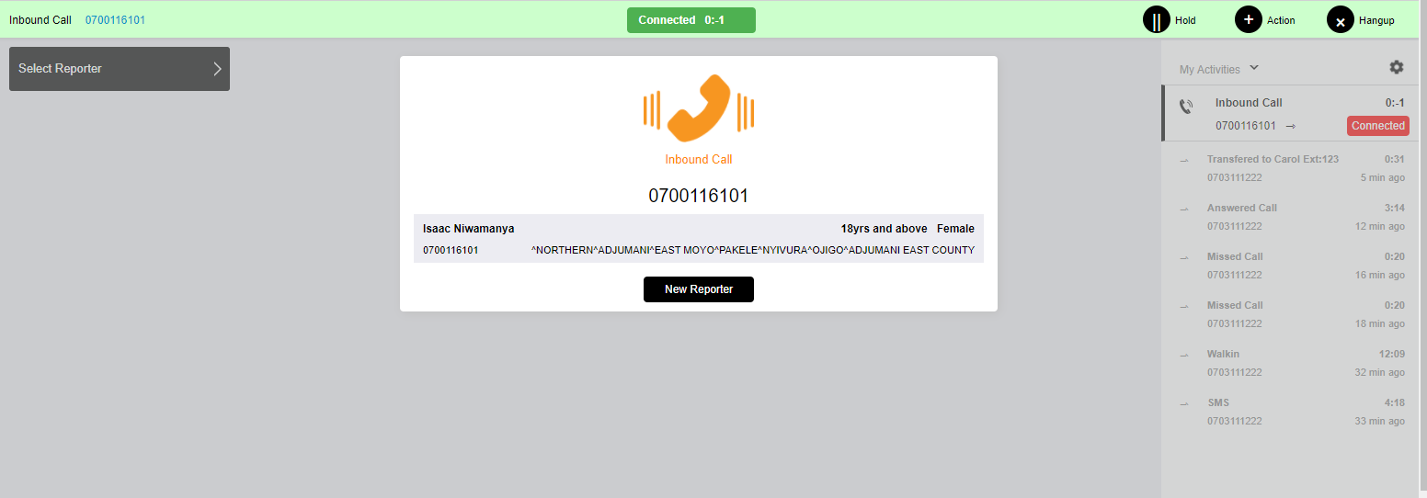

Figure : Incoming Call

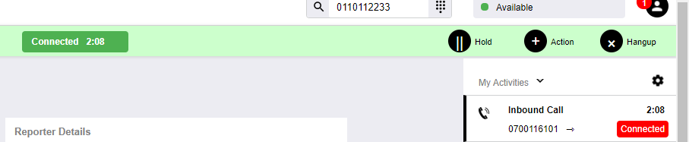

Figure : Incoming Call Options

When the user opts to hang-up a call, a form pops for them to give a reason as to why they are hanging-up on the caller before successfully disconnecting the caller.

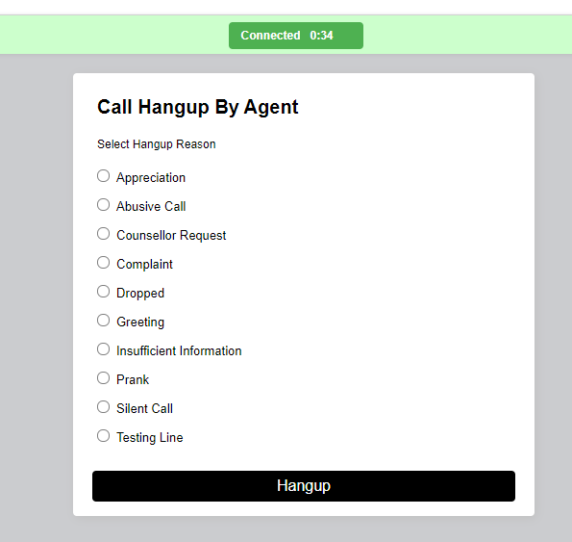

Figure : Hang-up Reasons

# Quality Assessment

QA is a role played by the supervisor to assess the quality of service in the calls made at the helpline. A QA form will pop up when a call record is selected for analysis and the audio recording tied to the call will start playing. The supervisor will listen to the recording as they rate it against the parameters set as shown below.

The QA button is located on the left side bar menu. It has three categories.

* Calls records
* Analyzed records
* Analysis reports

For each parameter chosen, a score will be displayed.

After filling the QA form, the supervisor will submit the form. The system will sum up the calculation and display the score on the specific agent. The system will also do an average of the call statistics and display on the monitoring wall.

Note The report above will list the calls that are yet to be analysed. The supervisor will click on the analyse link to perform QA.

QA form can be found under call record listing, calls that have not been analysed shall have a button for QA as active under the supervisor account.

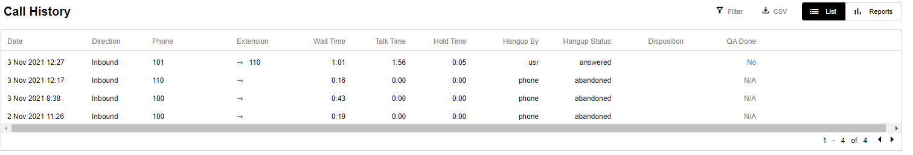

Figure : Call Listing For QA

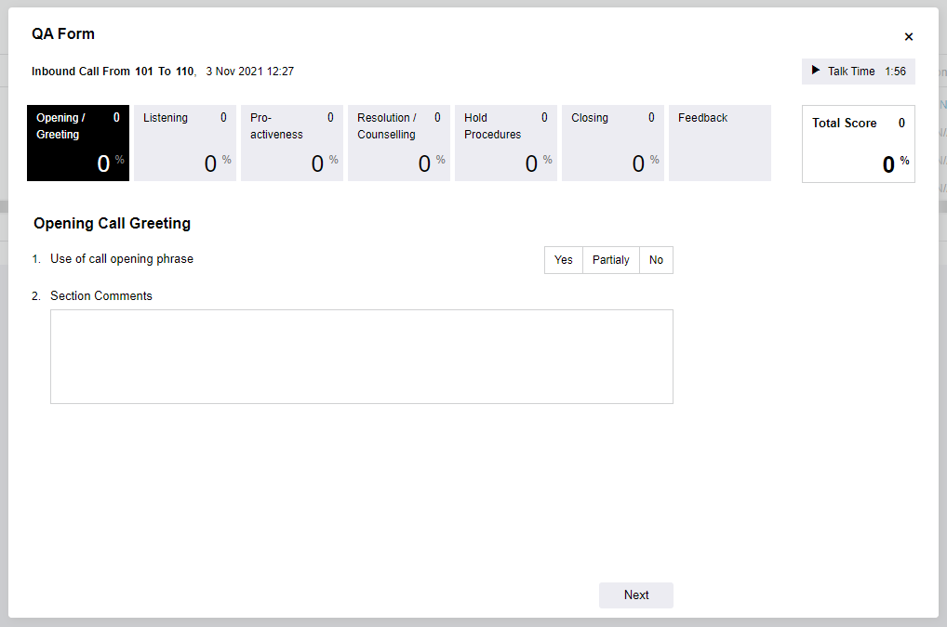

Figure : QA Form

The QA form is a step by step process with questions on every section having a score that adds to the total score. Once a section has been scored, the next button can be used to the next section. A previous button is available for succeeding sections.

The QA form has an audio player for the call recording, the audio player has controls for the user to pause, play or rewind the audio.

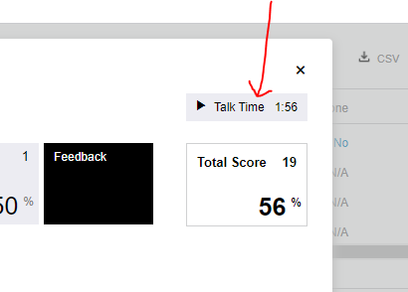

Figure : QA Audio Player

# Contact list

This is the list of all registered members. They are listed as a report exportable in CSV format.

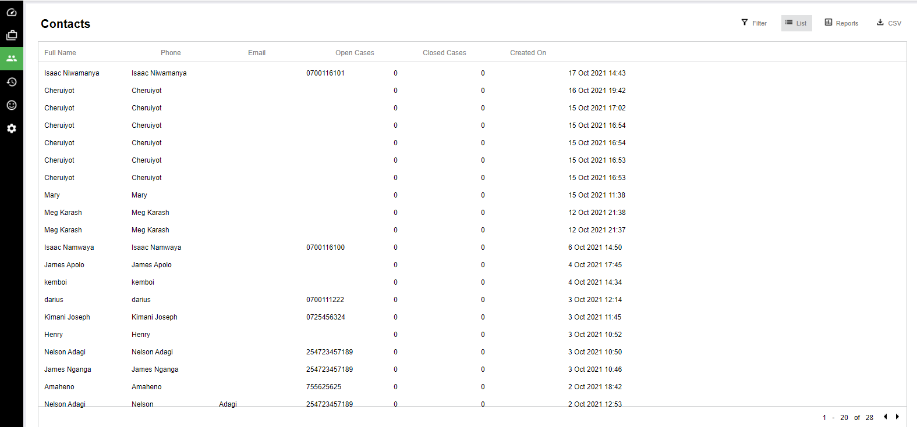

Figure :Contact List

Click on any of the contacts to view and to edit.

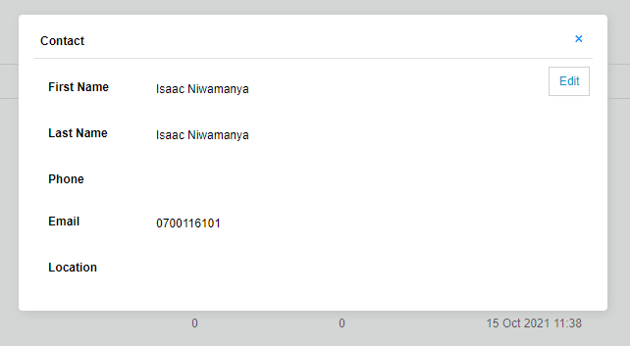

Figure :Individual Contact View

Edit contact form

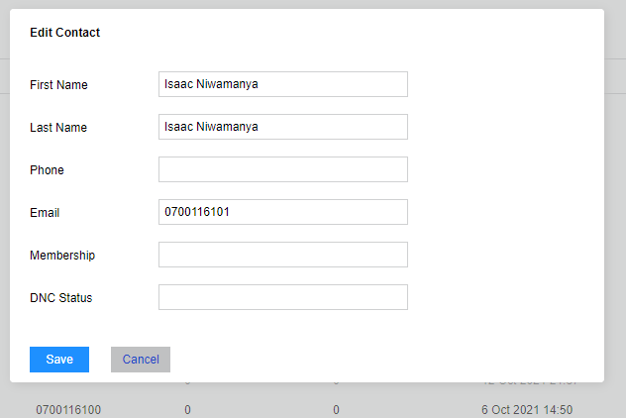

Figure : Individual Contact Edit

Every person contacting the centre in one way or another via the system shall be added to the contact list.

# Reports

The reports are divided into two major categories: call reports and Case reports each with both report listing and report pivots. Every report – call and case, has options which include: switching between list & pivot, download and filter.

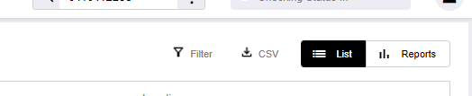

Figure : Report Options

## Call reports

### Call List

These are reports from incoming calls. The listing on the call reports is based on the standard call records and with relevant filters as per the related fields.

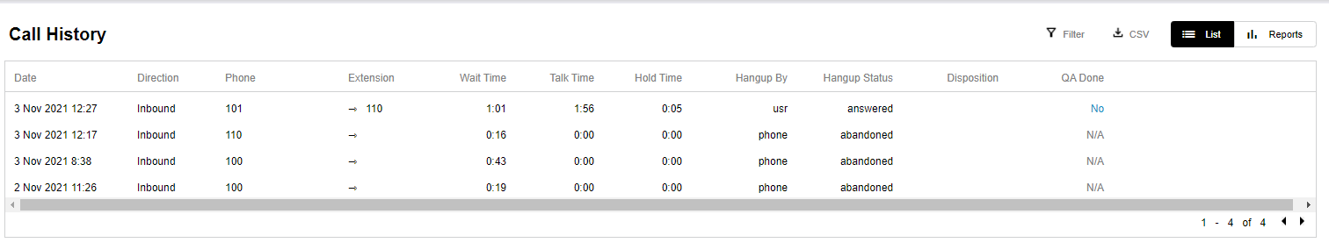

Figure : Call Record List

### Call Pivot Report

This give more flexibility in generating statistical reports numeric and graphical.

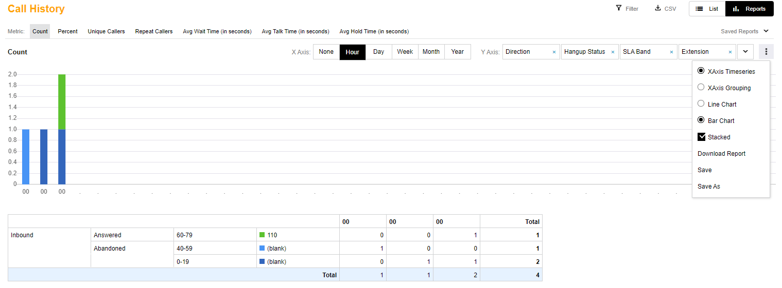

Figure : Call Pivot Reports

## Case reports

These are reports on cases created within the system irrespective of the case source, they have filters as per the case fields on the case capture and date created.

### Case List

This is a listing of the cases recorded on the helpline system with options to view and edit individual cases. The listing gives a brief understanding of the nature of cases in the columns displayed such as case source, category, location, gender among others.

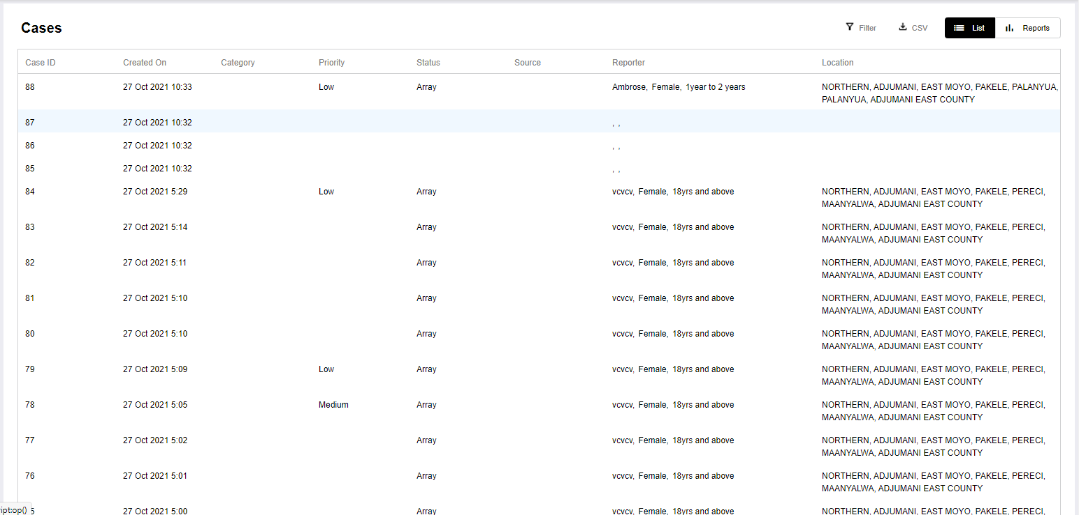

Figure : Case Report Listing

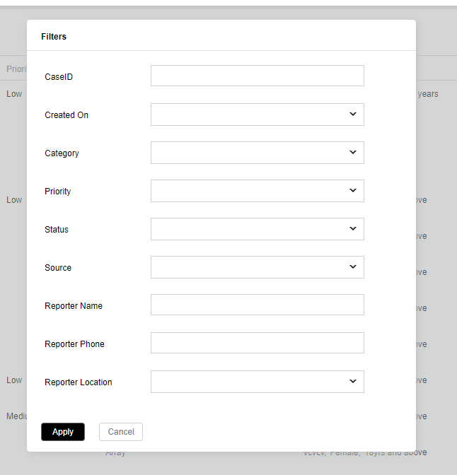

Figure : Case Report List Filters

### Case Report Pivot

Pivot reports are custom reports based on a X and Y axes matrix. The X-Axis based on time (Hour, Day, Week, Month and Year) and the Y-Axis based on the different available fields in the case capture.

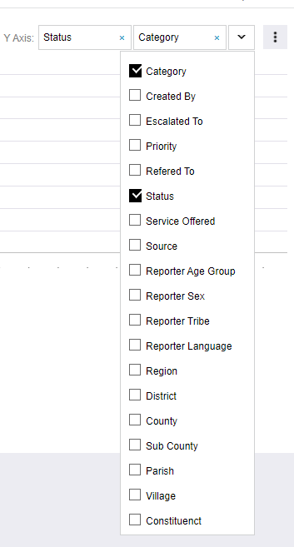

Figure : X-Axis Case Report Filters

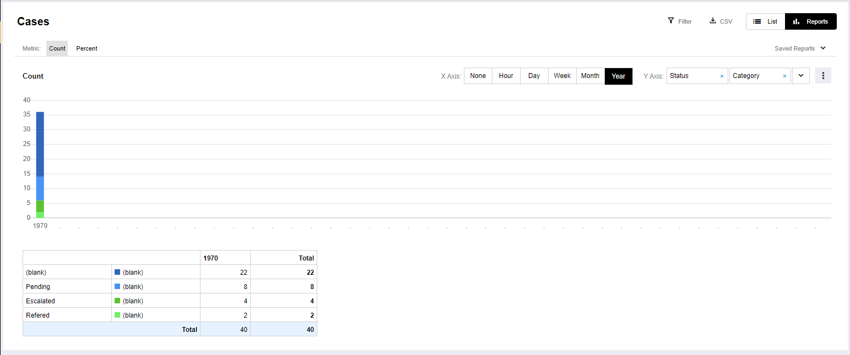

Figure : Case Pivot Report

# System Notifications & Other Sources

The system notifications are alerts to the users on what they need to act on or information on what is happening on the items related to them. Currently implemented to include incoming channels such as SMS, Email and any other media through which the system receives communication.

This is on the top-right corner as shown on the figure below:

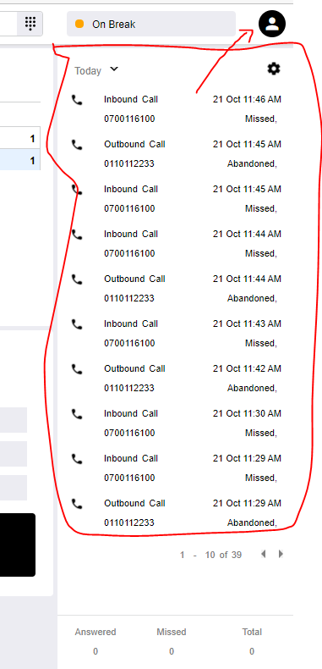

# Web Page

The web page is a display of information to the public about Sauti Helpline. It provides an option for one to submit/report a violence case which will be submitted to the center system and treated as an additional case source.



Figure : Web Online Case Report button

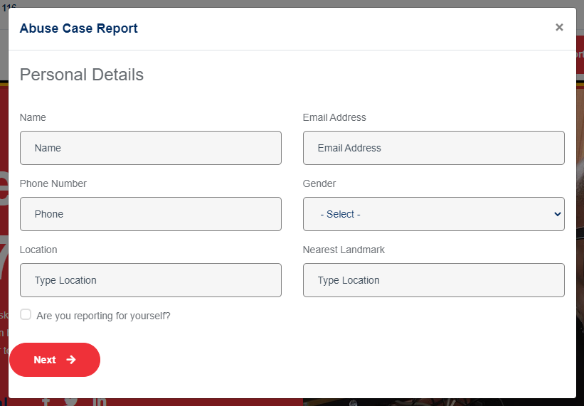

Figure : Web Online Case Report Form

The web online case form captures four main items: Reporter Details, Client Details, Perpetrator Details and case details.

Each case submitted to the system from the web online shall have a notification to the relevant system users.

# Mobile Application

# System Settings

This provides the system administrators with the power to change and/update dynamic items affecting system functionality. This currently has four items: Users, Campaigns, IVR prompts and Categories.



Figure : System Setting Options

## Users

The system users are created and updated at this point, as stated, this is a function reserved for system administrators.

It provides a listing of current users with view and edit options. A user view is available by clicking individual user whereby an option to edit shall be available.

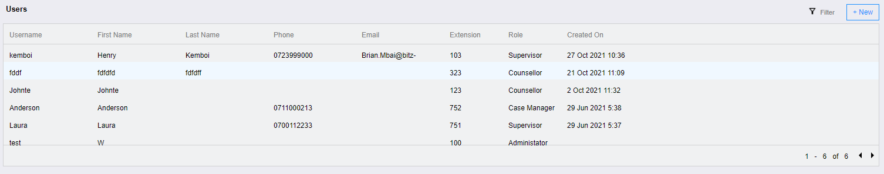

Figure : User Listing

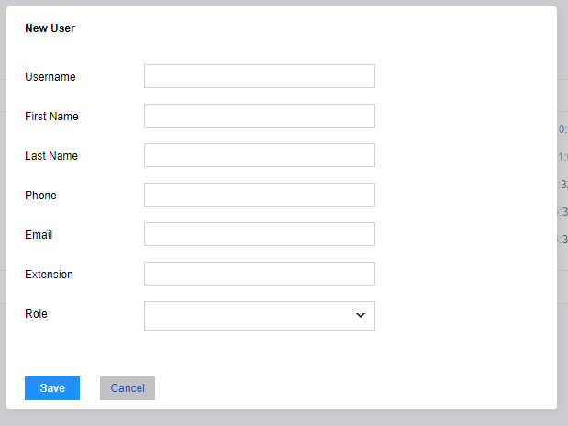

Figure : New User Form

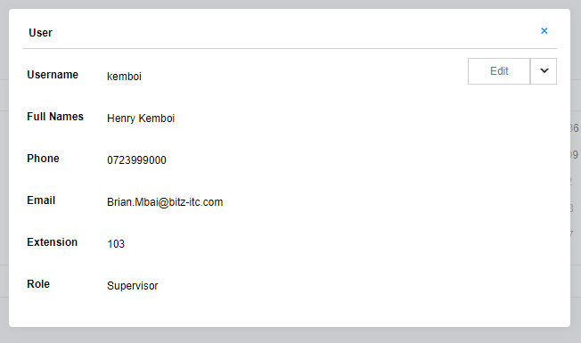

Figure : User View

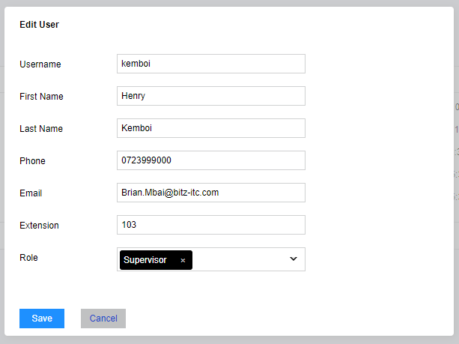

Figure : User Update Form

## Campaigns

This configuration allows the users to be assigned to different call campaigns in the system.

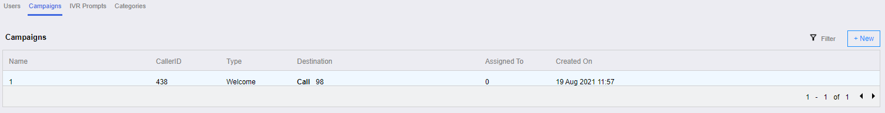

Figure : Campaign List

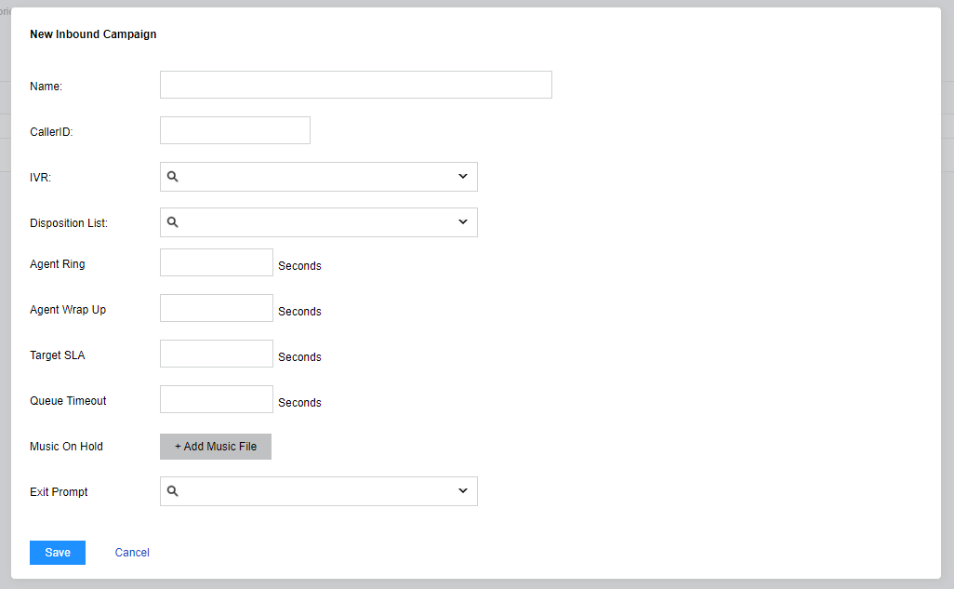Figure : New Campaign Form

## IVR Prompts

This provides for adding and updating call IVR prompts. It is presented in a tree view as shown the figure below. For a new item, click on add under the respective parent item and a field is presented for a new item.

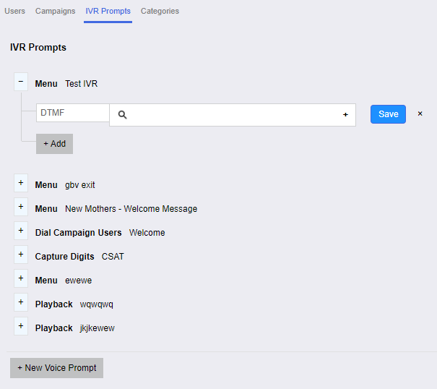

Figure : IVR Prompt View

## Categories

This is a provision for creating listing available for select options on the case form. They are presented in a tree-view as they are hierarchical. The presentation is as is in the diagram below:

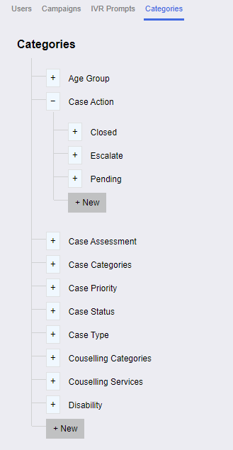

A “New” button is available under every category for adding new items.

# Conclusion

This user manual provides the directions for system use as provided by Bitz IT Consulting. This document is initially a replica of the solution’s first version and may be updated with further system upgrades.

# User Manual Sign-Off

|  |  |
| --- | --- |
| By signing this document, I acknowledge that I have received stated deliverables to the agreed quality levels. | |
|  | **Signature:** |
| **Date:** |
|  | **Signature:** |
| **Date:** |
| **Bitz IT Consulting Ltd: Director**  **Name:** James Nganga  **Email:** [james.nganga@bitz-itc.com](mailto:james.nganga@bitz-itc.com) | **Signature:** |
|  | **Date:** |